Hundreds of staff connect with telecare training
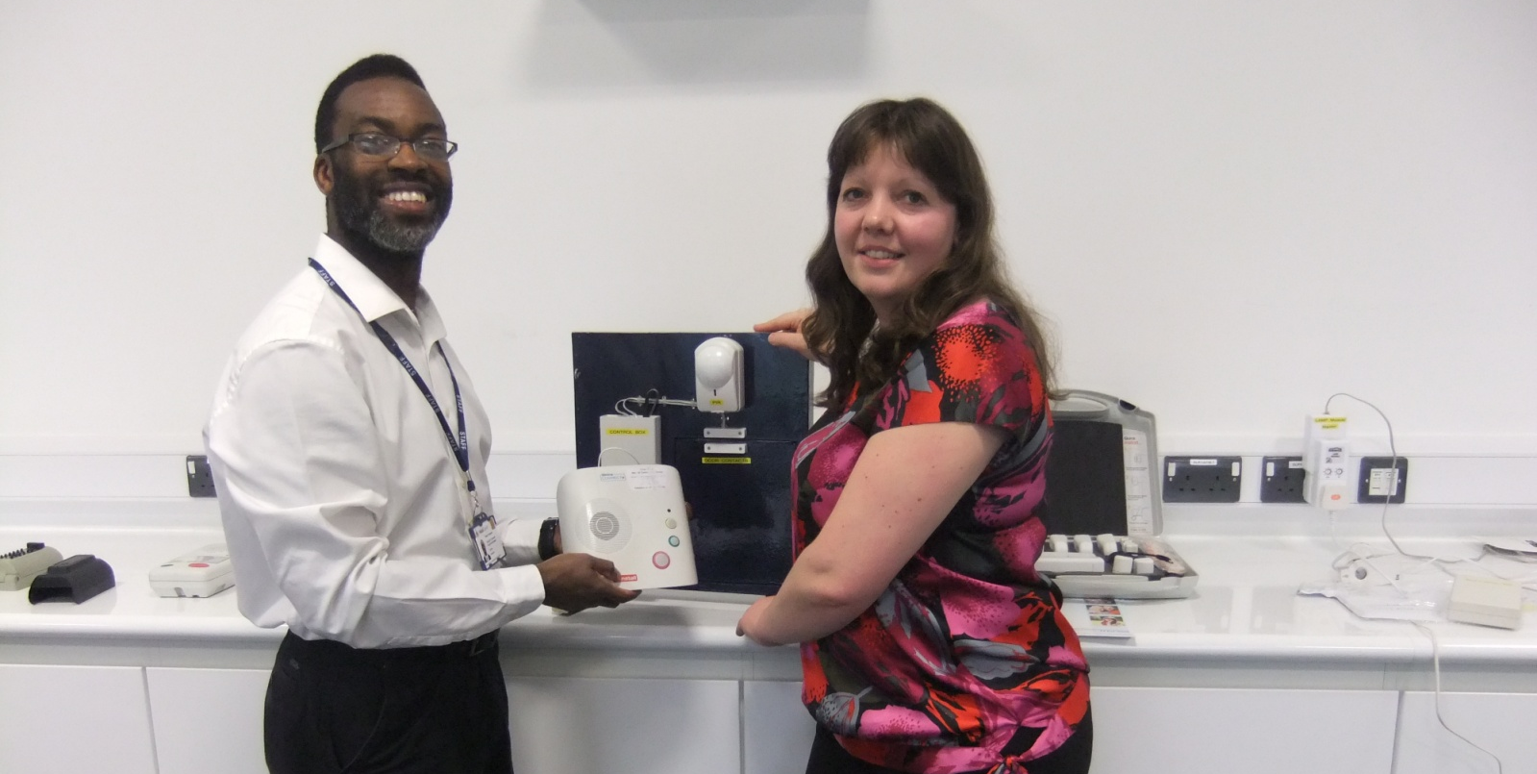

On a daily basis most of us put our laundry in the washing machine, load the dishwasher, text friends and family on our mobile phones and log on to our laptops.

We take these gadgets and labour-saving devices for granted and may even argue they’re essential to helping us lead our busy lives and aid our relaxation.

For Walsall’s rapidly growing older population and residents of all ages with a range of needs, technology is key to so much more than simply convenience.

It can mean the difference between being able to carry on living independently in your own home, in your own community, or having to go into residential care.

Assistive technology, known as telecare, can make this very difference and Walsall Council’s workforce development team has been helping hundreds of staff across all areas of the authority appreciate its role.

Over the last four months the team’s Trevor Thompson has been delivering half day training sessions for colleagues with Anne Abbotts from the Community Alarm Service to raise awareness of the devices available and help staff understand how Walsall’s residents can benefit from them.

“From pendants and wrist bands with a button people can press to raise an alarm, to medication reminders and epilepsy sensors, telecare offers a wide range of devices that really can make a difference to people’s lives,” explained Trevor.

“The training sessions show people exactly what sort of things are available and how they are helping the council and its partners to support people to continue living independently in their own homes.

“While we have had a high number of colleagues who work in social care and who produce support plans and work closely with service users attend the training, it is also beneficial for anyone who comes into contact with our borough’s residents and their families or carers.
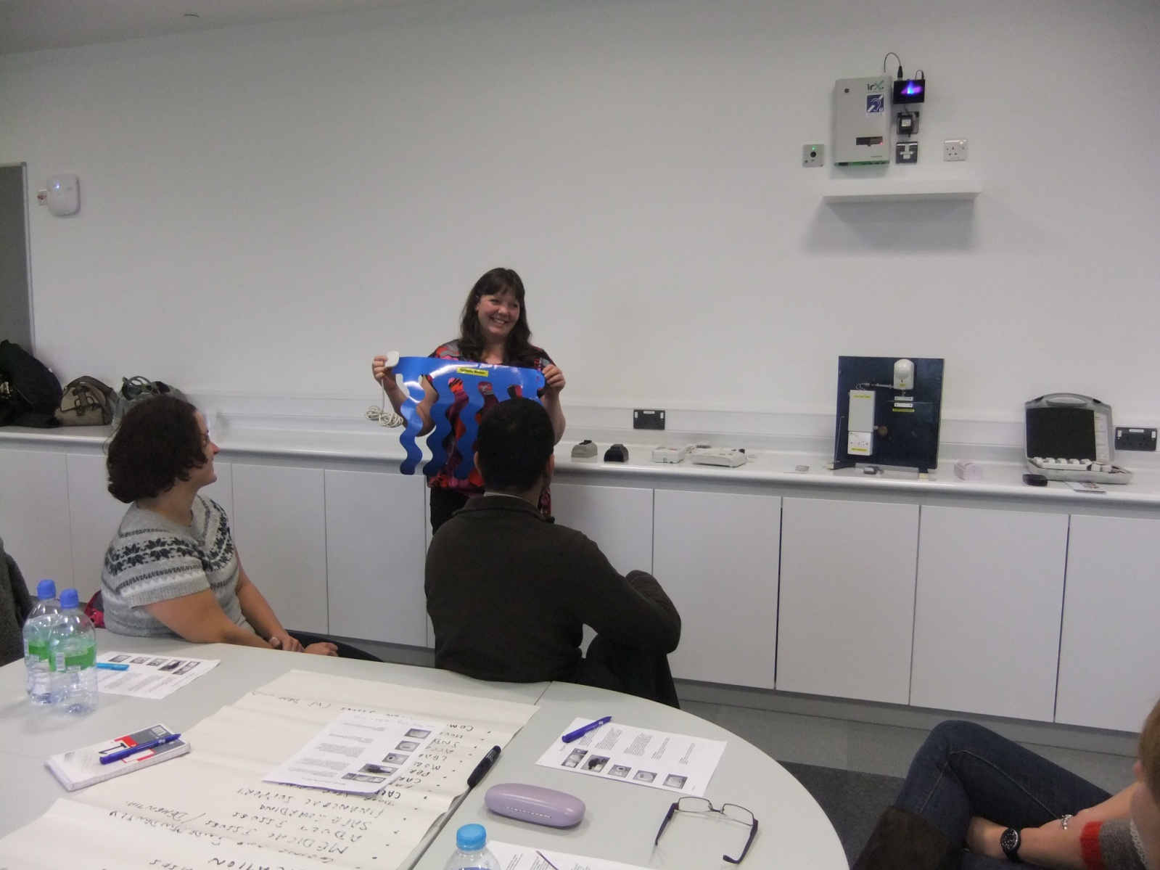
“We have all heard someone talk about an elderly relative or neighbour who is becoming forgetful and they might benefit from a medication dispenser which can show if tablets have been missed. Someone who has dementia and is prone to leave their property can have a door sensor fitted which provides an alert if the front door is open longer than it should be, indicating that someone has gone out and not come back.

“There are also epilepsy sensors that can be fitted to a bed which send an alert if someone is having a fit. People with epilepsy really value this device as not too long ago, relatives or carers would have had to sleep in their rooms to keep an eye on them. This meant a loss of privacy for them.

“The pendant or wrist band alarms that people have are linked to a 24 hour rapid response service and call operators at the Community Alarm Service have been able to send help to residents in all sorts of circumstances - including to one elderly gentleman whose home was on fire and who had just minutes to escape safely.”

Residents pay a £12.50 monthly fee for the rapid response service and any telecare devices they may have - including smoke detectors, temperature detectors, bogus official alert buttons and flood detectors. This service is free of charge to residents aged 80 and over.

Trevor added: “Years ago residents who were prone to regular falls or had certain conditions would have had to give up their homes and go into residential care. Telecare gives them the independence and confidence, with support, to stay in their own homes where they are happiest. It may also help prevent avoidable admissions to hospital.

“And it’s not just of benefit to more elderly residents. People with learning disabilities can also benefit.”

Telecare equipment can be viewed at the Independent Living centre in Wisemore and the training sessions, which have so far been attended by more than 300 staff, will continue in 2013.
As part of the session, attendees visit Primley House, at the Innovation Centre in Alumwell, which provides a home setting in which to demonstrate how telecare can be incorporated into people’s homes. It features a kitchen, dining area, living room, bedrooms and a bathroom.

“We’ve had good feedback from attendees and know that everyone who has been on the session will spread that knowledge further both to council colleagues and others which will help raise awareness more widely,” said Trevor.

“But most importantly, the message will better reach our residents and help them to stay safe, happy and well.”

