Honey and Mumford

Peter Honey and Alan Mumford’s learning style theory (1986) identifies four preferences.
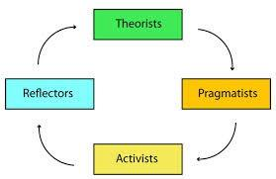
- Activist
- Reflector
- Theorist
- Pragmatist

Activists
Activists like to be involved in new experiences and ideas. They enjoy doing things and tend to act first and consider the implications afterwards. They don’t instinctively prepare for the learning experience or review their learning afterwards.

Activists learn best when they are involved in novel experiences, problems and opportunities. They prefer to working with others in team tasks, leading discussions and being thrown in at the deep end.

Reflectors
Reflectors like to view the situation from different perspectives. They like to collect data, review and think carefully before coming to any conclusions. They enjoy observing others and will listen to their views before offering their own.

Reflectors learn best when they are observing individuals or groups at work, reviewing what has happened and thinking about what they have learned and completing analyses and reports.

Theorists
Theorists like to adapt and integrate observations into complex and logically sound theories. They think problems through step- by-step and like to fit things into a rational scheme. Theorists learn best when they are put in complex situations where they have to use their skills and knowledge, have structured situations with a clear purpose and have the chance to question and probe ideas

Pragmatists
Pragmatists are practical, down to earth and like to try things out. They like concepts that can be applied to a task. Pragmatists learn best when there is a link between a topic and the task where they have the chance to try out techniques with obvious practical applications.

